Evaluating Earthquake Hazard and Risk: Moving from Point Pattern Analysis to Spatial Machine Learning and Exposure Modeling

Series 1: Spatial Data Integrity & Exploratory Spatial Data Analysis (ESDA)
- Central Question: What do raw seismic catalogue records actually represent, and where do spatial/reporting biases lie?
- Technical Level: Foundational GIS & Spatial Statistics.
- Skills: CRS transformation, Spatial Indexing, Point Pattern Analysis (Kernel Density Estimation, Nearest Neighbor Analysis), Catalogue Completeness ($M_c$).
- What to Build: QGIS map series showing global/regional distribution; Python script computing magnitude-frequency distributions (Gutenberg-Richter law check).
- What to Visualize: KDE surface map vs. Raw Point Density; Log-linear magnitude distribution plot.
- Employer Takeaway: Understands spatial distributions, statistical properties, and data quality flaws beyond simple cartography.
Series 2: Spatial Feature Engineering & Model Formulation
- Central Question: How do we convert spatial point records into tabular/raster representations suitable for Machine Learning without spatial leakage?
- Technical Level: Intermediate GeoAI / Data Science.
- Skills: Vector-to-raster processing, Spatial Distance Calculations, Spatial Buffering, Negative Sampling (pseudo-absences), Feature Extraction (distance to nearest fault, depth gradients, spatial density metrics).
- What to Build: A spatially explicit feature dataset in GeoPandas/PostGIS.
- What to Visualize: Feature correlation heatmap (including spatial distance metrics); Diagram of Spatial vs. Random Train/Test splitting.
- Employer Takeaway: Knows how to structure spatial ML problems correctly without falling into spatial autocorrelation traps.
Series 3: Spatial ML Modeling, Validation & Uncertainty
- Central Question: Can spatial ML accurately delineate earthquake susceptibility, and how does standard cross-validation misrepresent performance?
- Technical Level: Advanced GeoAI.
- Skills: Spatial Cross-Validation (spatialKFold), Random Forest / XGBoost, ROC-AUC evaluation, SHAP (SHapley Additive exPlanations) for spatial interpretability.
- What to Build: Python ML pipeline; Susceptibility prediction raster surface; Spatial error map (residual visualization).
- What to Visualize: Spatial CV split map vs. Random CV split map; Model performance drop in Spatial CV; SHAP feature importance plot.
- Employer Takeaway: Demonstrates advanced machine learning evaluation and spatial validation techniques.
Series 4: Coupling Hazard with Exposure — Spatial Risk Assessment
- Central Question: How do physical earthquake hazard surfaces intersect with human exposure and infrastructure vulnerability?
- Technical Level: Applied GIS & Decision Support.
- Skills: Spatial Overlays, Map Algebra, Exposure Modeling (Gridded Population Data integration like WorldPop/GHSL), Spatial Multi-Criteria Evaluation (SMCE).
- What to Build: Comprehensive Spatial Risk Index raster layer; Exposure breakdown by administrative units.
- What to Visualize: Bivariate map showing Hazard (Susceptibility) vs. Exposure (Population Density); Vulnerability overlay.
- Employer Takeaway: Can translate complex spatial-statistical output into actionable business or humanitarian decision support.
Day 1:
Cartography & GIS: Moving from Point Pattern Analysis to GeoAI
I’m working through a 20-year global earthquake dataset (2000–2020) in QGIS, and my biggest takeaway so far hasn't been about software tools—it's been about data integrity and fundamental cartographic choices.
Here are a few things I adjusted in my workflow:
- Moving away from Shapefiles: They truncate field names at 10 characters and handle datetimes poorly. I moved all layers (Natural Earth Landcover, GEM Active Faults, and Earthquakes) into an OGC GeoPackage (.gpkg) to keep the data schema intact and leverage spatial indexing.
- Choosing the right projection: Standard Web Mercator introduces severe area distortion near the poles, which skews global density perception. I reprojected the map to Equal Earth Greenwich (EPSG:8857) to keep relative surface areas mathematically honest.
- Accounting for human visual bias: While visualizing the top 10 deadliest earthquakes, standard proportional circle sizing felt off. Humans naturally underestimate circle areas as they grow larger. I applied Flannery Perceptual Scaling in QGIS to adjust symbol sizes for how the human eye actually perceives area.
- Eliminating map clutter: I stripped out the oversized North Arrow and heavy basemap styling. On a global, North-up equal-area map, extra decorative elements just add visual noise and distract from the actual data.
If the underlying spatial data or projection choice is flawed, any analysis built on top of it falls apart. Next, I'm moving beyond point mapping toward spatial density modeling and proximity analysis against active fault lines.

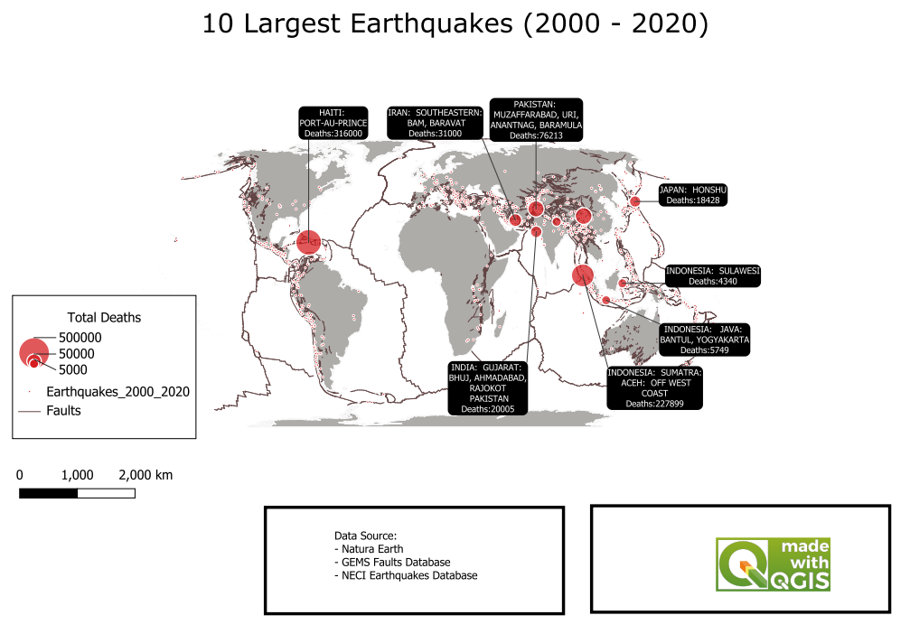Twitter / X Thread
1/5 Cartography & GIS: Moving from Point Pattern Analysis to GeoAI
Cleaning up a 20-year global earthquake dataset in QGIS. Realized how easy it is to make a misleading map if you stick to default software settings. Here are 4 core takeaways from my workflow:
2/5 1. Moving away from Shapefiles: They truncate field names at 10 characters and handle datetimes poorly. I moved all layers (Landcover, GEM Active Faults, Earthquakes) into an OGC GeoPackage (.gpkg) to keep the schema intact and utilize spatial indexing.
3/5 2. Choosing the right projection: Standard Web Mercator introduces severe area distortion near the poles, which skews global density perception. I reprojected the map to Equal Earth Greenwich (EPSG:8857) to keep relative surface areas honest.
4/5 3. Accounting for human visual bias: When visualizing the top 10 deadliest earthquakes, linear circle sizing fails because humans naturally underestimate larger circle areas. I applied Flannery Perceptual Scaling in QGIS to adjust symbol sizes for true visual perception.
5/5 4. Eliminating map clutter: I stripped out the oversized North Arrow and heavy basemaps. On a global, North-up equal-area map, extra elements just add visual noise.

